**Experiment 8**

**Date:** 18-02-2021

**Aim:** To simulate FCFS scheduling algorithm using C programming language.

**Software Used:** Code Blocks IDE

**\*Code:**

#include<stdio.h>

int main()

{ int arival_time[10],arival_time2[10],burst_time[100],ex[100],seq[100],re[100],wt[100],tat[100];

int n,i,j,start,position,max_time=0,min_time,idle=0,k=0;

float av1=0,av2=0;

printf("Enter number of process\n");

scanf("%d",&n);

printf("Enter arrival time for processes\n");

for(i=0;i<n;i++)

{

scanf("%d",&arival_time[i]);

arival_time2[i]=arival_time[i];

}

printf("Enter burst time for processes\n");

for(i=0;i<n;i++)

{

scanf("%d",&burst_time[i]);

}

start=arival_time[0];

for(i=1;i<n;i++)

{

if(start>arival_time[i])

{

start=arival_time[i];

}

}

printf("Sequence of execution is\n");

for(i=0;i<n;i++)

{

if(max_time<arival_time[i])

{

max_time=arival_time[i];

}

}

max_time=max_time+1;

for(i=0;i<n;i++,k++)

{ min_time=max_time;

for(j=0;j<n;j++){

if(arival_time[j]!=-1)

{

if(arival_time[j]<min_time)

{

min_time=arival_time[j];

position=j;

}

} }

printf("[P%d] ",position);

seq[k]=position;

if(start<arival_time[position]){

re[position]=start;

idle+=arival_time[position]-start;

start=arival_time[position];

start+=burst_time[position];

arival_time[position]=-1;

ex[position]=start;

}

else{

re[position]=start;

start+=burst_time[position];

arival_time[position]=-1;

ex[position]=start;

}

}

printf("\n");

for(i=0;i<n;i++)

{

tat[i]=ex[i]-arival_time2[i];

wt[i]=tat[i]-burst_time[i];

}

printf("Process Arrival-time(s) Burst-time(s) Waiting-time(s) Turnaround-time(s)\n");

for(i=0;i<n;i++)

{

printf("P%d %d %d %d %d\n",i,arival_time2[i],burst_time[i],wt[i],tat[i]);

}

for(i=0;i<n;i++)

{

av1+=tat[i];

av2+=wt[i];

}

printf("Average waiting time(s) %f\nAverage turnaroundtime(s) %f\nCPU idle time(s)%d\n",av2/n,av1/n,idle);

}

**Output:**

**Case 1:** Zero Arrival Time

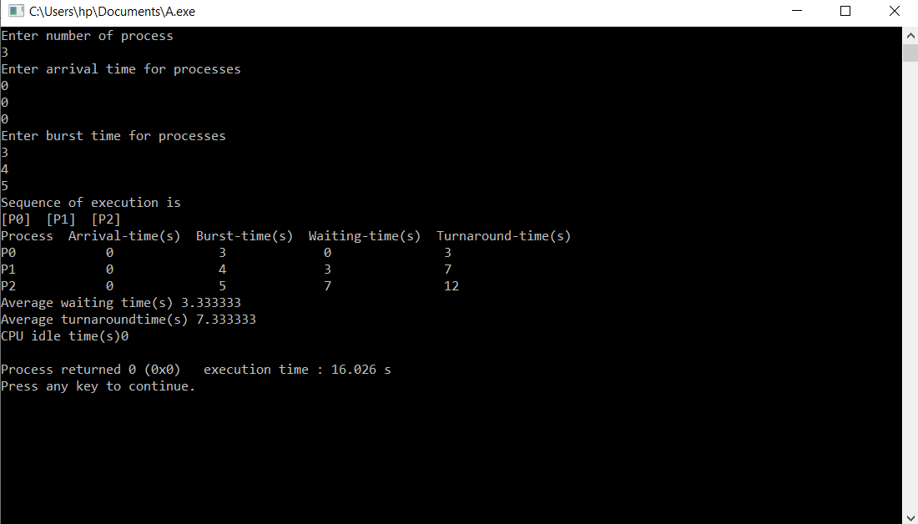

**Case 2:** Different Arrival Time

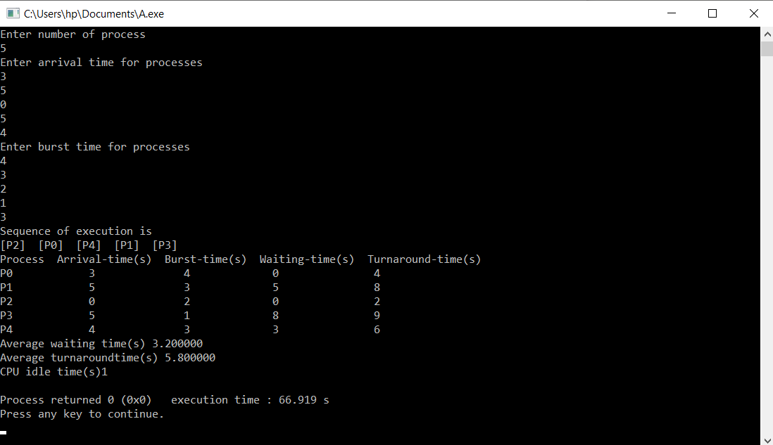

**Conclusion:** The simulation of FCFS algorithm has been done successfully.